**Genetic Switches between two population with regards to mRNA and proteins applying Markov Chain Stochastic Model Check**

**1Qin He,** **2 RubinWang,** **3 XiaochuanPan**

123 East China University of Science and Technology, Meilong 130

Email: 1asamiko@aliyun.com, 2rbwang@163.com, 3pxc@ecust.edu.cn

Contact No.: 1+447782976863, 2+8613341667006, 3+8613501707512

**Abstract:**. As Arc, one virus-like gene, crucial for learning and memory, was dis-covered by researchers in neurological disorders fields, Arc mRNA’s single directed path and allowing protein binding regional restric-tively is a potential investigation on helping shuttle toxic proteins responsible for some diseases related to memory deficiency. To study especially the transform between mRNA and proteins, the switching function of the phenotypes, ’normals’ multiplying populations and ’persisters’, resilient to stress instead of multiplying is of our interest. Mean time to switching (MTS) is calculated explicitly quantifying the switching process in statistical methods combining Hamiltonian Markov Chain(HMC).The model derived from predator and prey with typeII functional response studies the mechanism of normals with intrin-sic rate of increase and the persisters with the instantaneous discovery rate and converting coefficients. During solving the results, since the numeric method is applied for the 2D approximation of Hamiltonion with intrinsic noise induced switching combining geometric minimum action method. In the application of Hamiltonian Markov Chain, the behavior of the convertion (between mRNA and proteins through 6 states from off to on ) is described with probabilistic conditional logic formula and the final concentration is computed with both Continuous and Discret Time Markov Chain(CTMC/DTMC) through Embedding and Switching Diffusion.The MTS, trajectories and Hamiltonian dynamics demonstrate the practical and robust advantages of our model on interpreting the switching process of genes (IGFs, Hax Arcs and etc.) with respects to memory deficiency in aging process which can be useful in further drug efficiency test and disease curing.

***Index******terms:***switching model, mean time to switching, Hamiltonian Markov Chain, geometric minimum action method.

1. **INTRODUCTION**

In cell biology, non-equilibrium stochastic process is of interest since the observation of experimental results are becoming of higher res -olution, studying the molecules both with imaging and expression data are often conducted in both single and population (thousand) order, which basically described in stochastic process whether on a discrete or continuous scale with status changes either genotypi-cally or phenotypically. Many problems are thus studied related to status switching, including cell regulatory networks[1], signal re-sponse on excitability and inhibition[2], (convinced by translational and transcriptional burst of expression for instances.), metastability among populations, (binding of ligands and proteins, forming of polymerases and etc.).In this paper, we focus on the interaction among genes, mRNA, proteins and etc. To be more specific, while the switching problem among molecules can be studied on geno-type, including sequencing for single RNA, alignments and binding considering condons

and etc, we stay on the switching with expres-sion (concentration) only, which is simplified as modified population problem using Lotka-Volterra equations[3] of two populations only. Thus, rather than the competitor model(for instances, cell bifurcations.), we applied simulation of switching on predator model. The model is based on the following basic assumptions: Prey population (promoters) is fed with enough food all the time while the predator population of the predator(the persisters) depends on the size of prey(promoters).

In our paper, we mainly study the interaction of DNA and its interaction with the associated proteins.(Clinical data of Hax1 and HS1 is downloaded from Ensmbl gene database[4]). On one hand, the switching model is calculated under the large deviation theory(LDT)[5] combining the least actions. The Markov chain[6] consider the states of the 2D coordinates (x; y) of mRNA numbers and protein numbers referencing the distribution of x, which follows the order O(1) while PX follows the time scale on O(1/e) and guaran-teeing the variant of LDT hold with the transform of the expressions in single population. Only considering the process of diffusion case, we study the binding of hax1 with simple switching between on and off status under its interaction with HS1 seen as in the constant environment, i.e. the closed system at mean field. The dimer which can be cancelled out connect the binding between two single population. On the other hand, one numeric method is applied to solve the problem, making compare with the stochastic process[7] on ap-proximation equation of the mean switching time(MST) with the transform between two status (we studied the switching time with four situations, both multiplicative and asymptotic of single population and the binding and degradation between two population.) Again, this method is also calculated based on the Hamiltonians. We give out the MST with respect to N/Nc denoting N as the population number of interest and Nc as the threshold of certain status(either of that population or the other population). Since our study only based on data in the process of transforming in the constant environment, extinction is not considered in this paper. To study both intrinsic and extrinsic noise with the exciting and inhibiting bursts is the potential topic in the future. In the following contents, the first chapter is the proposition of the model, based on least action with LDT and MTS approximation with one stochastic differential equation (SDE) [8]separately; And the second chapter gives numeric experiments based on Hamilton Markov Chain[9] computation of the expression data of hax1 and HS1; In the last chapter, the model is described in the normal logic formula with both probabilistic condition model[10] and the results are analysed with both hamiltonian, realization size, convergence, the rewards computation taking the CTMC as Poisson process[11] and the reachability computation with the transfer kernel of switching diffusion[12] through DTMC. In the appendix, there also includes the complete proof of model with action S based on Hamilton not only based on the explicit equation in this paper. Some descriptive statistics and pre-computation based on the data can be accessed through link in availability. As the process related to motor coordination and func-tion, the Hax’s function in regulation, B cell’s signal transduction can be further studied with more data considering its excitability and metastability functions with stimulation of drugs for instance in the future as well. And one computation applying DTMC withlinear regression on previous work is made as the further extension of the model.

1. **Proposed Model**

Molecular interactions are studied on phenotypic data of the mRNA and its associated protein in this paper,especially the trajectory of the production of hax1 and HS1 with interaction with each other through least action method combining diffusion process[10]. Furthermore, in solving the equation, one stochastic differentiation equation approximates the analytic solution and calculation of MST[11] based on converging with Hamiltonian quantities, finding three convergence points through eigenvalue of position quantities as well as satisfying H = 0 and Hq = 0 where q(P X ; PY ) are momentum quantities. In the 3rd subsection, the transition is illustrated with belief graph first and then convert ratio are utilized in computing the discrete embedding of the continuous temporal logic. As comparison, the third subsection compute the discretized time markov chain as the approximation considering it as a hybrid systems.

1. switching model with least action

First of all,we consider the dynamics of population of the interaction involved systems as diffusion[12], and thus the Hamiltonian H(x,θ) is computed with the minimization of action (quasi-potential)[13] instead of some other methods, for instance WKB[14]. With the Lagrangian denoted with respect to Hamiltonian according to LDT:

$$L(x,y) = sup θ∈R_{ n} (< y,θ > -H(x,θ)) =< y,θ(x,y) > -H(x,θ(x,y))$$

Due to the maximizer θ(x,y) being implicitly defined by

Hθ(x,θ(x,y)) = y, we calculate the action from quasi-potential: $${V(x1,x2) =inf}_{T>0} {infψ∈C}_{x1 (0,T)}^{x2}ST(ψ)$$

$$= \inf_{T>0} inf{ φ∈C}_{x1(0,1) }^{ x2}{infψ∈C}_{x1 (0,T)}^{x2}ST(ψ)= inf{ φ∈C}_{x1(0,1) }^{ x2}S(φ)$$

So that for any φ ∈ C(0,1) the action S(φ) is given by the equivalent four formula:

$${ S(φ) =inf}_{T>0} {infψ∈C}_{x1 (0,T)}^{x2}ST(ψ)$$

$${ S(φ) =sup⁡inf}_{θ:\left[0,1\right]→ H\left(φ,θ\right)=0}$$

$${ S(φ) \int_{0}^{1}{<φ’,θ(φ,φ’)>dα}}_{}$$

$$S\left(φ\right)=dα,λ = λ(φ,φ’)$$

Note that L(x, y) is the Lagrangian associated with the Hamiltonian H(x,θ) with function θ(x,y) and λ(x,y) are implicitly defined for all x ∈ D and y ∈ R n /0 as the unique solution (solution(θ,λ) ∈ R n X[0,inf) of the system possessing zero value when φ 0 = 0 or λ(φ,φ 0 ) = 0 setting the integrands to zero with: H(x,θ) = 0,H θ (x,θ) = λy,≤ lambda where the lower bounds for S(φ) is directly achieved:

$${ S(φ) =inf}_{T>0} {infψ∈C}_{x1 (0,T)}^{x2}S_{T}(ψ)$$

$$≥ \int_{0}^{1}{sup⁡\inf_{H\left(φ,θ\right)=0}^{θ:\left[0,1\right]} <φ’,θ)>dα}$$

$$≥ \int_{0}^{1}{ <φ’,θ(φ,φ’))>dα}$$

$$\int_{0}^{1}{<φ’,θ(φ,φ’)>dα}$$

utilizing the first equation of the four. Furthermore, S(φ) ‘s upper bound can also be obtained through defining a minimizing sequences (T k ,ψ k ) ,k∈N with the following rescaling process: For every k ∈N let:λk(α)= max(λ(φ(α),φ 0 (α)),1/k),α ∈ [0,1], B k (α) =dα,α ∈ [0,1], T k(α) = B k (1), B k (t)=φ($B_{k}^{-1}$ (t)),t∈ [0,Tk ] Specifically, the inverse of Bk is approximated with the Brownian standard σx satisfying the α0(t)=λ k (α(t)) and thus 1/k≤ α‘(t) ≤ |λk| inf ≤ inf holds for all t ∈ [0,Tk ] with the absolute continuity of α(t) . And thus, the ψk is continuous in the whole time sequence (0, T k ), enabling the inverse process: t =t(α) = G k (α) with dt = dα/λk and φ‘ (α) = ψ’k (t)G’k (α) =ψk(t)’/λk(α).

Thus, $S_{T}{\left(ψ\right)==\int{} }_{0}^{T_{k}}L(φ,{φλ}_{k}^{'})/λ_{k}^{}dα$

leading to the upper bound switching the integrate and limitation

with k− > inf , and with the proof in appendix B(in another work

with landscape model) fufilling the first order and second order conditions: φ’ =Hθ (φ,θ)/λ is negative definite during the θ maximizing process: L(φ,λ∗φ 0 )/λ = supθ∈Rn (< phi’ ,θ> − H(φ,θ)/λ) and guaranteeing them both fufiled by θ = θ(φ,φ’) with the second equation, so that upper bound here is the same as the integrands of the lower bound as well as holds the θ = 0 when the λ = 0 is satisfied, and therefore:

L(φ,λ∗φ‘)/λ =<φ’, θ > − H(φ,θ)/λ=< φ 0 ,θ >,θ = θ(φ,φ’)

The calculation can be found completely in Appendix B.

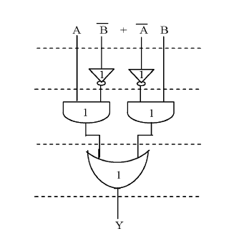

**Figure 1: Delay and Area evaluation of an XOR gate**.

Table 1

Delay and Area Evaluation of the Basic Blocks of CSLA

Basic Blocks Delay Area

XOR 3 5

2:1 MUX 3 4

Half Adder 3 6

Full Adder 6 13

1. **BASIC STRUCTURE OF BEC LOGIC**

conventional carry select adder performs better in terms of speed. The delay of our proposed design increases lightly because of logic circuit sharing sacrifices the length of parallel path.

However, the proposed area-efficient carry select adder retains partial parallel computation architecture as the conventional carry select adder area and power consumption of the regular CSLA. To replace the n-bit RCA, an n+1-bit BEC is required. A structure and the function table of a 4-bit BEC are shown in Figure.2 and Table .2, respectively.

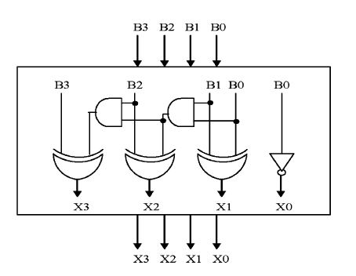

**Figure 2: 4-Bit BEC**

The Boolean expressions of the 4-bit BEC are

X0 = ~B0 (1)

X1 = B0^B1 (2)

X2 = B2^ (B0 & B1) (3)

X3 = B3^ (B0 & B1 & B2) (4)

**Table.2 Function table of the 4-bit BEC**

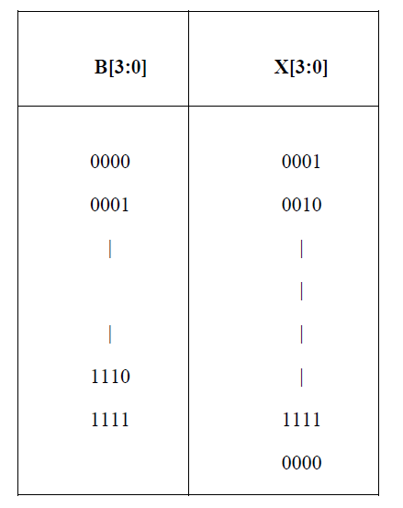

1. **BASIC STRUCTURE OF REGULAR 16-BIT CSLA**

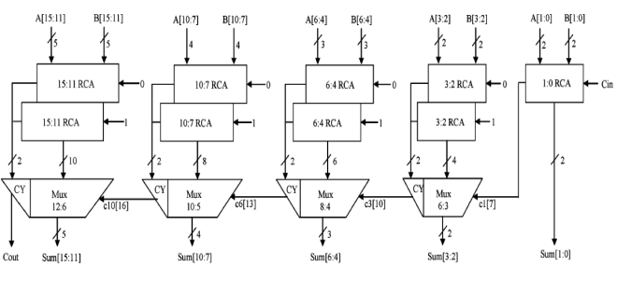

**Figure 3: Regular CSLA circuit**

The structure of the 16-b regular SQRT CS conventional carry select adder performs better in terms of speed. The delay of our proposed design increases lightly because of logic circuit sharing sacrifices the length of parallel path.

However, the proposed area-efficient carry select adder retains partial parallel computation architecture as the conventional carry select adder

{c6, sum [6:4]} = c3 [t=10] +mux (5)

{c10, sum [10:7]} = c6 [t=13] +mux (6)

{Cout, sum [15:11]}=c10 [t=16] +mux. (7)

3) The one set of 2-b RCA in group2 has 2 FA for Cin=1 and the other set has 1 FA and 1 HA for Cin=0. Based on the area count of Table I, the total number of gate counts in group2 is determined as follows:

Gate Count = 57 (FA+HA+MUX) (8)

FA=39(3*13) (9)

HA=6(1*6) (10)

MUX=12(3*4) (11)

4) Similarly, the estimated maximum delay and area of the other groups in the regular SQRT CSLA are evaluated and listed in Table 3.

Table 3

Group Delay Area

2 11 57

3 13 87

4 16 117

5 19 147

1. **DELAY AND AREA EVALUATION OF CSLA USING BEC CONVERTER**

.

The structure of the proposed 16-b SQRT CSLA using BEC for RCA with Cin=1 to optimize the area and power is shown in Fig. 4. We again split the structure into five groups. The steps leading to the conventional carry select adder performs better in terms of speed. The delay of our proposed design increases lightly because of logic circuit sharing sacrifices the length of parallel path

However, the proposed area-efficient carry select adder retains partial parallel computation architecture as the conventional carry select adder) are depending on s3and mux and partial c3 (input to mux) and mux, respectively. The sum2 depends on c1 and mux.

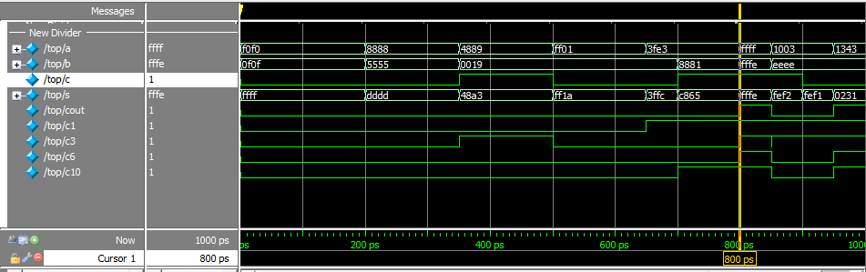2) For the remaining group’s the arrival time of mux selection input is always greater than the arrival time of data inputs from the BEC’s. Thus, the delay of the remaining groups depends on the arrival time of mux selection input and the mux delay.

3) The area count of group2 is determined as follows:

Gate count =43(FA+HA+MUX+BEC) (12)

FA= 13(1*13) (13)

HA=6(1*6) (14)

AND=NOT=1 (15)

XOR=10(2*5) (16)

MUX=12(3*4) (17)

4) Similarly, the estimated maximum delay and area of the other groups of the modified SQRT CSLA are evaluated and listed in Table 4.

Table 4

Group Delay Area

2 13 43

3 16 61

4 19 84

5 22 107

Comparing Tables 3and 4, it is clear that the proposed modified CSLA saves 113 gate areas than the regular CSLA, with only 11 increases in gate delays.

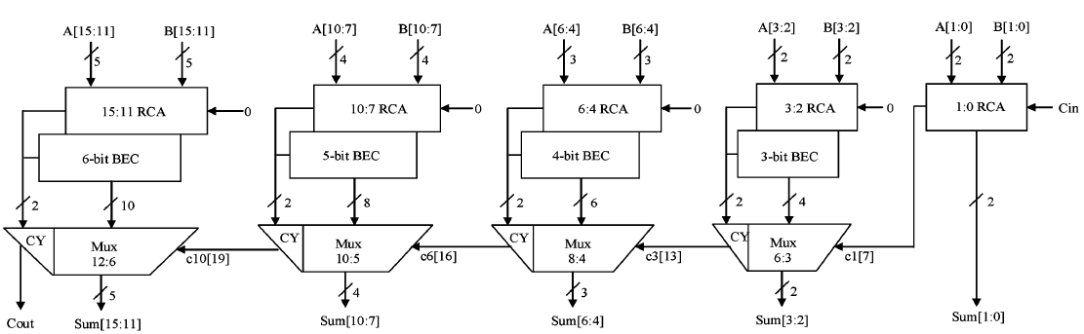

**Figure 4: CSLA circuit using BEC Converter**

1. **SIMULATIONS AND EXPERIMENTAL RESULTS**

The proposed solutions have been designed using Xilinx. The area-efficient carry select adder can also achieve an outstanding performance in power consumption. Power consumption can be greatly saved in our proposed area-efficient carry select adder because we only need one XOR gate and one INV gate in each summation operation as well as one AND gate and one OR gate in each carry-out operation after logic simplification and sharing partial circuit. Because of hardware sharing, we can also significantly reduce the occurring chance of glitch. Besides, the improvement of power consumption can be more obvious as the input bit number increases.

**Figure 5: Simulated Results**

The conventional carry select adder performs better in terms of speed. The delay of our proposed design increases lightly because of logic circuit sharing sacrifices the length of parallel path.

However, the proposed area-efficient carry select adder retains partial parallel computation architecture as the conventional carry select adder design; the delay increment of the proposed design is similar to that in the conventional design as the input bit number increases. We also simulated the delay performance in the proposed area-efficient adder and conventional carry select adder with 4, 8, 16, and 32-bit respectively.

**CONCLUSION**

Implemented with any type of adder to further improve the speed. Using Binary to Excess-1 Converter (BEC) instead of RCA in the regular CSLA we can achieve lower area and power consumption. The main advantage of this BEC logic comes from the lesser number of logic gates than the Full Adder (FA) structure.is therefore, low area, low power, simple and efficient A to excess-1 code converters (BEC) to improve the speed of addition. This logic can be for VLSI hardware implementation.

**REFERENCES**

[1] O. J. Bedrij, “Carry-select adder,” *IRE Trans. Electron. Comput,* pp. 340–344, 1962.

[2] B. Ramkumar, H.M. Kittur, and P. M. Kannan, “ASIC implementation of modified faster carry save adder,” *Eur. J. Sci. Res.*, vol. 42, no. 1, pp.53–58, 2010.

[3] T. Y. Ceiang and M. J. Hsiao, “Carry-select adder using single ripple carry adder,” *Electron. Lett.*, vol. 34, no. 22, pp. 2101–2103, Oct. 1998.

[4] J. M. Rabaey*, Digtal Integrated Circuits— A Design Perspective* Upper Saddle River, NJ: Prentice-Hall, 2001

[5] J. M. Rabaey*, Digtal Integrated Circuits— A Design Perspective* Upper Saddle River, NJ: Prentice-Hall, 2001.

[6] Y. He, C. H. Chang, and J. Gu, “An area efficient 64-bit square root carry-select adder for lowpower applications,” in *Proc. IEEE Int. Symp. Circuits Syst.*, 2005, vol. 4, pp. 4082–4085.

[7] Cadence, “Encounter user guide,” Version 6.2.4, March 2008

★★★